Review of Management Controls for the Arrow Squid Jigging Fishery (SQU 1J) in 2016

MPI Discussion Paper No: 2016/12

Prepared for consultation by the Ministry for Primary Industries

ISBN No: 978-1-77665-268-6 (online)
ISSN No: 2253-3907 (online)

June 2016

Disclaimer
The information in this publication is not government policy. While every effort has been made to ensure the information is accurate, the Ministry for Primary Industries does not accept any responsibility or liability for error of fact, omission, interpretation or opinion that may be present, nor for the consequences of any decisions based on this information. Any view or opinion expressed does not necessarily represent the view of the Ministry for Primary Industries.

Requests for further copies should be directed to:
Publications Logistics Officer
Ministry for Primary Industries
PO Box 2526
WELLINGTON 6140
Email: brand@mpi.govt.nz
Telephone: 0800 00 83 33
Facsimile: 04-894 0300
This publication is also available on the Ministry for Primary Industries website at
http://www.mpi.govt.nz/news-resources/publications.aspx
© Crown Copyright - Ministry for Primary Industries
Contents Page

1 Submission Information 1
1.1 Official Information Act 1982 1
2 Executive Summary 2
3 Purpose 3
3.1 Need for action 3
3.2 Management approach 3
4 Background Information 4
4.1 Biological characteristics of squid 4
4.2 Commercial fishery 4
4.3 Recreational fishery 5
4.4 Māori customary fishery 5
4.5 Other sources of fishing-related mortality 5
4.6 Previous review 5
4.7 Science information 5
5 Legal Considerations 6
5.1 Setting management measures 6
5.2 Further considerations 6
5.2.1 Seabirds, mammals, and protected fish 7
5.2.2 Benthic impacts 7
6 Proposed Options 7
6.1 Option 1 7
6.2 Option 2 8
6.3 Option 3 8
7 Other Matters 8
7.1 Deemed values 8
8 Conclusion 8

Submission Information
MPI welcomes written submissions on any or all of the proposals contained in the Consultation Document. All written submissions must be received by MPI no later than 5pm on Monday 11 July 2016.

Written submissions should be sent directly to:
Deepwater Fisheries Management
Ministry for Primary Industries
P O Box 2526
Wellington 6011

or emailed to FMsubmissions@mpi.govt.nz

Official Information Act 1982
All submissions are subject to the Official Information Act and can be released (along with personal details of the submitter) under the Act. If you have specific reasons for wanting to have your submission or personal details withheld, please set out your reasons in the submission. MPI will consider those reasons when making any assessment for the release of submissions if requested under the Official Information Act.

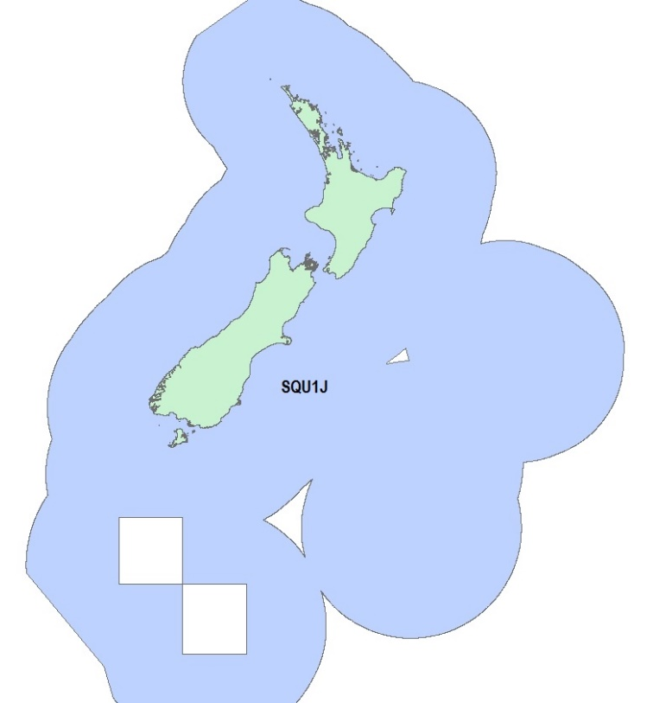

Figure 1: Quota management area (QMA) for the squid jigging fishery (SQU 1J)

Executive Summary
The Ministry for Primary Industries (MPI) is seeking information and views from tangata whenua and stakeholders to inform a review of catch limits for the arrow squid jigging fishstock SQU 1J. Arrow squid (wheketere) were introduced into the quota management system (QMS) in 1987 with quota management areas (QMAs) set based on a combination of fishing method and geographical area. Three QMAs were set, two method-specific (SQU 1J and SQU 1T) and one standard QMA (SQU 6T). The SQU 1J QMA (Figure 1) is defined as all New Zealand fisheries waters other than the Kermadec and Southern Islands Area with a method of fishing of jigging (being any fishing method for taking squid by means of a line rather than a net).

The initial total allowable commercial catch (TACC) set in 1987 was 57,705 tonnes based on historical catches achieved during the early 1980s when over 200 vessels were active in the fishery. Over the next ten years the TACC fluctuated due to Quota Appeal Authority (QAA) decisions and catch limit reviews. The TACC has not been adjusted since 1996/97 when it was set at 50,212 tonnes.

The squid jig fleet that fished in New Zealand was historically made up almost entirely of specialised fishing vessels flagged to a number of different Asian countries. Since 1990, over 97% of reported SQU 1J landings were attributed to foreign charter vessels. Landings of SQU 1J have never reached the TACC. Since 2006/07, no more than five vessels have operated in the fishery in a given year resulting in annual catches being less than 5% of the TACC.

MPI’s initial proposals for catch limits for SQU 1J are set out in Table 1:

Table 1: Proposed management settings for SQU 1J (all values in tonnes)
Option | Total Allowable Catch | Total Allowable Commercial Catch | Allowances
 |  |  | Customary Māori | Recreational | Other sources of fishing-related mortality
Option 1 (Status quo) | 50,242 | 50,212 | 10 | 10 | 10
Option 2 | 10,030 | 10,000 | 10 | 10 | 10
Option 3 | 5,030 | 5,000 | 10 | 10 | 10

Purpose

Need for action
The current TACC for the SQU 1J stock was based on historical catches achieved during the early 1980s when over 200 squid jigging vessels were active in the fishery. Amendments to the Fisheries Act 1996 (the Act) came into force on 1 May 2016 which require all fishing vessels to be flagged to New Zealand. MPI understands it will be difficult for vessels such as squid jiggers that wish to operate on a seasonal basis to re-flag to New Zealand. The re-flagging requirement means that the level of effort that the TACC was based on is unlikely to be repeated. There is no sustainability concern but maintaining the TACC at historical levels is not considered appropriate in this context.

Management approach
Arrow squid is a Tier 1 fish stock managed under the National Fisheries Plan for Deepwater and Middle-depth Fisheries (National Deepwater Plan), which was approved by the Minister of Fisheries under section 11A of the Fisheries Act 1996. Within the National Deepwater Plan it is classed as a Tier 2 stock. Tier 1 fisheries are high volume and/or high value fisheries and are traditionally targeted. Tier 2 fisheries are typically less valuable bycatch fisheries or are only target fisheries at certain times of the year. SQU 1J is treated as a Tier 2 fish stock because of the low volume of catches.

Squid are listed on Schedule 3 of the Fisheries Act 1996 (the Act). Therefore the Minister may set a TAC under s 14 of the Act if satisfied that the purpose of the Act would be better achieved otherwise than by setting a TAC under s 13 (which requires the setting of a TAC based on B_{MSY}). Squid are in this category because of the biological characteristics of this species (discussed below).

Background Information

Biological characteristics of squid
The New Zealand arrow squid fishery is based on two related species Nototodarus gouldi and Nototodarus sloanii. N. gouldi is mainly found around mainland New Zealand north of the Subtropical Convergence, whereas N. sloanii is mainly found to the south of the convergence zone. Both species are found across the continental shelf in waters up to 500m in depth, though they are most commonly found in waters less than 300m in depth. Both species are sexually dimorphic, though similar in biology and appearance. They can grow to a length of 34 cm, with females being larger than males.

Arrow squid live for one year, spawn once then die. Every squid fishing season is based on what amounts to a new stock meaning that it is not possible to calculate estimates of sustainable yield. Furthermore, because of the short life span and rapid growth of arrow squid, it is not possible to estimate the biomass prior to the fishing season.

Commercial fishery
The New Zealand squid jigging fishery began in the late 1970’s. Jigging is a method of catching squid by continuously lowering and retrieving lines from the fishing vessel. The majority of squid jigging takes place in the summer/autumn months from January through to May. Fishing is often done at night when squid are attracted by powerful lights on the vessel. The number of vessels that have reported landing SQU 1J, together with landed catch and the SQU 1J TACC since the 1990/91 fishing year, is shown in Figure 2 below.

The initial TACC set in 1987 was 57,705 tonnes. Over the next three years this was gradually increased as a result of Quota Appeal Authority (QAA) decisions, reaching a maximum of 76,136 tonnes in 1989/90. In 1990/91 the TACC was reduced by around 30,000 tonnes to 46,087 tonnes before another QAA decision increased the TACC to 50,212 tonnes, where it has remained since the 1996/97 fishing year (Figure 2). Since 1994/95, SQU 1J catch levels and effort has decreased and have never exceeded 35,000 tonnes. A maximum of five vessels have operated in the fishery since 2006/07. The lowest annual landing was 167 tonnes in 2013/14.

Figure 2: SQU 1J reported landings and TACC (left axis) and number of vessels operating in the fishery (right axis) between 1990/91 and 2014/15

Recreational fishery
No quantitative information is available on the current level of arrow squid caught by recreational fishers but under the new TAC an allowance of 10 tonnes is proposed for the first time.

Māori customary fishery
No quantitative information is available on the current level of customary non-commercial take but under the new TAC an allowance of 10 tonnes is proposed for the first time.

Other sources of fishing-related mortality
MPI does not have any estimates of these other sources of fishing-related mortality but under the new TAC an allowance of 10 tonnes is proposed for the first time.

Previous review
The TACC was last increased in 1996/97 from 46,087 tonnes to 50,212 tonnes as the result of a QAA decision.

Science information
No estimates of current and reference biomass are available. There is also no proven method at this time to estimate yields from the squid fishery before a fishing season begins. Because squid live for about one year, spawn and then die, and because the fishery is so variable, it is not practical to predict future stock size in advance of the fishing season. But this can be managed by an appropriately set baseline TAC plus the ability to do in-season increases to the TAC.

It is not known whether New Zealand squid stocks have ever been stressed through fishing mortality. A recent attempt was made to run an in-season stock assessment of squid but was not considered useful as a management tool.

Legal Considerations

Setting management measures
As noted above squid are listed on Schedule 3 of the Fisheries Act 1996 (the Act). Therefore the Minister may set a TAC under s 14 of the Act if satisfied that the purpose of the Act would be better achieved otherwise than by setting a TAC under s 13 (which requires the setting of a TAC based on B_{MSY}).

Since squid is listed on Schedule 3, there is power under s14(6) to do in-season increases to the TAC. The in-season increase applies for the fishing year in which it is done and the TAC reverts to the baseline TAC at the end of the fishing year. This paper is concerned only with setting an appropriate baseline TAC but the in-season increase power is an important part of the management regime for squid given its biological characteristics.

Three options are proposed for the TACC. The amount of squid taken by recreational and Māori customary is not known however allowances are proposed to be ten (10) tonnes for each of the three options under the TAC for the first time. Other sources of fishing related mortality are unknown but it is proposed to set a ten (10) tonne allowance under the TAC for the first time for each of the three options.

The proposed large reductions in TACC to near current catch levels combined with the ability to do in-season increases, are considered to be a better way of achieving the purpose of the Act in relation to this species and is more consistent with the objectives of the fisheries plan for deepwater fisheries.

Further considerations
Sections 9(a) and (b) of the Act require the Minister to take into account that associated or dependent species be maintained at or above a level that ensures their long-term viability, and that the biological diversity of the aquatic environment should be maintained. The key environmental interactions associated with the SQU 1J fishery are discussed below.
Section 10 of the Act requires that all persons exercising or performing functions, duties, or powers under this Act, in relation to the utilisation of fisheries resources or ensuring sustainability, shall take into account that decisions should be based on the best available information, that decision makers should consider any uncertainty in the information available in any case, that decision makers should be cautious when information is uncertain, unreliable, or inadequate and the absence of, or any uncertainty in, any information should not be used as a reason for postponing or failing to take any measure to achieve the purpose of the Act.

Seabirds, mammals, and protected fish
There are no known marine mammal or protected fish interactions in SQU 1J, however seabirds are caught. Management of seabird interactions with New Zealand’s commercial fisheries is driven through the 2013 National Plan of Action to Reduce the Incidental Captures of Seabirds in New Zealand fisheries (NPOA Seabirds). The NPOA Seabirds reflects New Zealand’s obligations under customary international law to take into account the effects of fishing on associated species such as seabirds. Observer coverage in SQU 1J has historically been low, but in the last two fishing years (2013/14 and 2014/15), there was 100% observer coverage on two Japanese squid jiggers. These data record incidental captures of 32 seabirds, the majority of which were sooty shearwaters. The risk from commercial fisheries to the New Zealand population of sooty shearwater was assessed in 2011 as negligible.

Benthic impacts
There are no known benthic impacts from the squid jigging method.

Proposed Options
The TACC for SQU 1J has never been fully caught (Figure 2) and is based on a historical level of effort that is unlikely to be repeated due to the re-flagging requirement which came into force on 1 May 2016. Maintaining the TACC at historical levels may not be appropriate in this context.

The following three options are proposed for consideration (Table 2). There has not been an allowance set for recreational, customary catch or other sources of fishing related mortality under a TAC. For all three options it is proposed to set recreational, Māori customary allowances and other sources of fishing related mortality allowances at ten (10) tonnes each for the first time under the TAC.

Table 2: Proposed management settings for SQU 1J (all values in tonnes)
Option | Total Allowable Catch | Total Allowable Commercial Catch | Allowances
 |  |  | Customary Māori | Recreational | Other sources of fishing-related mortality
Option 1 (Status quo) | 50,242 | 50,212 | 10 | 10 | 10
Option 2 | 10,030 | 10,000 | 10 | 10 | 10
Option 3 | 5,030 | 5,000 | 10 | 10 | 10

Option 1
Under Option 1, the TAC would be set at 50,242 tonnes and the recreational, Māori customary allowances and other sources of fishing related mortality allowances would be set at ten (10) tonnes each. The existing TACC would be retained (status quo).

Option 2
Option 2 involves an approximately 80% decrease in the TACC to 10,000 tonnes. It has been 11 years since this level of catch occurred in SQU 1J. Effort was much higher in 2004/05 when 20 jigging vessels were in the fishery. It is proposed to set recreational, Māori customary allowances and other sources of fishing related mortality allowances at ten (10) tonnes each for the first time under the TAC.

Option 3
Option 3 involves an approximately 90% decrease in the TACC to 5,000 tonnes. It has been 10 years since this level of catch occurred in SQU 1J. It is proposed to set recreational, Māori customary allowances and other sources of fishing related mortality allowances at ten (10) tonnes each for the first time under the TAC.

Other Matters

Deemed values
Deemed values are an economic tool that incentivises commercial fishers not to catch in excess of their individual annual catch entitlements. The current Interim Deemed Value is $0.44 and the current Annual Deemed Value is $0.88. It is proposed that these values remain the same.

Conclusion
MPI is seeking information and views from tangata whenua and stakeholders to support the development of final advice to the Minister on management settings for SQU 1J for the fishing year commencing 1 October 2016. Landings of SQU 1J have never reached the current TACC and have not exceeded 5% of the TACC since 2006/07. A maximum of only five vessels have operated in the fishery in the last decade. MPI proposes three options; the status quo, and two large reductions in TACC.

Thompson F. Berkenbusch K. (2016) Preparation of data of observed protected species captures, 2002–03 to 2014–15 Draft report prepared for the Ministry for Primary Industries.
Abraham E. R., Thompson F. N. (2012). Captures of sooty shearwater in trawl fisheries, in the New Zealand Exclusive Economic Zone, from 2002–03 to 2010–11.

