Review of Management Controls for the John Dory 7 Fishery (JDO 7) in 2016

MPI Discussion Paper No: 2016/13

Prepared for consultation by the Ministry for Primary Industries

ISBN No: 978-1-77665-269-3 (online)
ISSN No: 2253-3907 (online)

June 2016

Disclaimer
The information in this publication is not government policy. While every effort has been made to ensure the information is accurate, the Ministry for Primary Industries does not accept any responsibility or liability for error of fact, omission, interpretation or opinion that may be present, nor for the consequences of any decisions based on this information. Any view or opinion expressed does not necessarily represent the view of the Ministry for Primary Industries.
Requests for further copies should be directed to:
Publications Logistics Officer
Ministry for Primary Industries
PO Box 2526
WELLINGTON 6140
Email: brand@mpi.govt.nz
Telephone: 0800 00 83 33
Facsimile: 04-894 0300
This publication is also available on the Ministry for Primary Industries website at
http://www.mpi.govt.nz/news-resources/publications.aspx
© Crown Copyright - Ministry for Primary Industries
Contents Page

1 Submission Information 2
Official Information Act 1982 2
2 Executive Summary 3
3 Purpose 4
3.1 Need for action 4
3.2 Management approach 4
4 Background Information 4
4.1 Biological characteristics of John dory 4
4.2 Commercial fishery 5
4.3 Recreational fishery 5
4.4 Māori customary fishery 6
4.5 Other sources of fishing-related mortality 6
4.6 Previous review 6
4.7 New information 7
5 Legal Considerations 7
5.1 Setting management measures 7
5.2 Further considerations 8
5.2.1 Seabirds, mammals, and protected fish 8
5.2.2 Benthic impacts 8
6 Proposed Response 9
6.1 Option 1 9
6.2 Option 2 9
6.3 Option 3 10
7 Other Matters 11
7.1 Deemed values 11
7.2 Recreational controls 11
8 Conclusion 11

Submission Information
The Ministry for Primary Industries (MPI) welcomes written submissions on any or all of the proposals contained in the Discussion Document. All written submissions must be received by MPI no later than 5pm on Monday 11 July 2016.

Written submissions should be sent directly to:
Inshore Fisheries Management
Ministry for Primary Industries
P O Box 2526
Wellington 6011

or emailed to FMsubmissions@mpi.govt.nz

Official Information Act 1982
All submissions are subject to the Official Information Act and can be released (along with personal details of the submitter) under the Act. If you have specific reasons for wanting to have your submission or personal details withheld, please set out your reasons in the submission. MPI will consider those reasons when making any assessment for the release of submissions if requested under the Official Information Act.

John Dory (JDO 7)

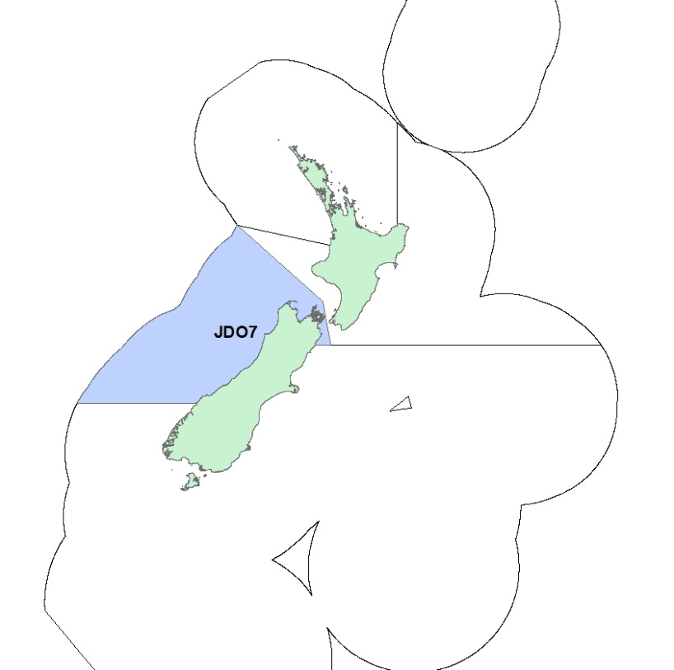

Figure 1: Quota management area (QMA) for JDO 7

Executive Summary
The Ministry for Primary Industries (MPI) is seeking information and views from tangata whenua and stakeholders to inform a review of catch limits and allowances for John dory (Zeus faber) in quota management area (QMA) 7 (JDO 7; Figure 1).

MPI proposes the following options for the upcoming fishing year (Table 1):

Table 1: Proposed TACs, TACCs and allowances for JDO 7 (all values in tonnes)
Option | Total Allowable Catch | Total Allowable Commercial Catch | Allowances
 |  |  | Customary Māori | Recreational | Other sources of fishing-related mortality
Option 1 (Status quo) | 161 | 150 | 1 | 2 | 8
Option 2 | 185 | 170 | 2 | 4 | 9
Option 3 | 206 | 190 | 2 | 4 | 10

The increases are proposed because the biomass estimates from the most recent trawl survey are the highest recorded. Recruitment is also higher than 2011 and 2013 and almost as strong as 2009. Recreational harvest, while relatively low, is most likely exceeding the recreational allowance and the TACC has been met or slightly exceeded for the previous two fishing years since it was raised to 150 tonnes. Two options for increase are proposed for stakeholder comment.

The management settings for the 2016/17 fishing year would remain in place until another review is undertaken. While a future review could occur ahead of any fishing year MPI considers it most likely that the settings would stay in place until at least 2018 to allow for the gathering of additional information and the further development of a management approach for JDO 7 as part of a planned wider inshore finfish fisheries initiative to improve certainty about management interventions.

MPI is seeking tangata whenua and stakeholder information and views on the proposed options to support the development of final advice for decision by the Minister for Primary Industries.

Purpose

3.1 Need for action
The best available information from the most recent West Coast South Island trawl survey shows JDO 7 biomass is likely (>60%) to be above B_{MSY}.

It is expected that this level of biomass will remain in the fishery for the next two to four years. MPI considers that the increased abundance provides opportunities for additional utilisation while ensuring sustainability.

3.2 Management approach
The WCSI trawl surveys have been accepted as providing an index of abundance and used to determine a proxy biomass target (the mean total biomass from the surveys between 1992 and 2011) for JDO 7.

A specific harvest strategy that provides guidance on how best to respond to new information on JDO 7 is not currently in place. MPI is currently in initial stages of a project to develop management approaches for stocks like JDO7 to provide greater certainty about when and how management intervention will be undertaken.

In the interim, options proposed for the upcoming fishing year reflect the best available information. While a future review could occur ahead of any future fishing year, it is most likely that a review would next be considered for JDO 7 in 2018 when new WCSI trawl survey information is scheduled to become available.

Background Information

4.1 Biological characteristics of John dory
John dory are widespread, being found in the eastern Atlantic Ocean, the Mediterranean Sea and around New Zealand, Australia and Japan. They are common in the inshore coastal waters of northern New Zealand, and to a lesser extent in Tasman Bay, to depths of 50 m.

John dory are serial spawners (spawning more than once in a season). There appears to be substantial variation in the time of spawning in New Zealand, with spawning occurring between December and April on the northeast coast. The eggs are large and pelagic, taking 12–14 days to hatch. Initially John dory grow rapidly with both males and females reaching 12 to 18 cm standard length (SL) after the first year. From the second year onwards females grow faster than males and reach a greater maximum length. Females mature at a size of 29 to 35 cm SL and in general, larger females mature earlier in the season and are more fecund. Males mature at 23 to 29 cm SL. John dory have a maximum age of 12 years.

These characteristics mean John dory populations can fluctuate widely as a result of fluctuations in recruitment.

Large fluctuations in stock biomass can provide opportunities for increased utilisation when strong year classes appear in the population. Large fluctuations in stock biomass also mean management measures are required to rapidly reduce catches at times of persistent low recruitment.

4.2 Commercial fishery
John dory in JDO 7 is predominantly caught by bottom trawl targeting flatfish (25%), barracouta (23%) and tarakihi (18%). Interdependencies between these stocks and other species occur as a consequence of being taken as part of a mixed inshore trawl fishery. Landings from JDO 7 increased markedly after 1999/2000, as a result of increasing abundance. No data were available for JDO setnet fisheries in the South Island.

The JDO 7 TACC has been increased three times since 2003/04 and is currently 150 tonnes (Figure 2). JDO 7 commercial catch has been exceeded five out of the last 10 fishing years. Since the TACC was increased in 2012/2013 the TACC has been exceeded once by 742 kg (less than 1%).
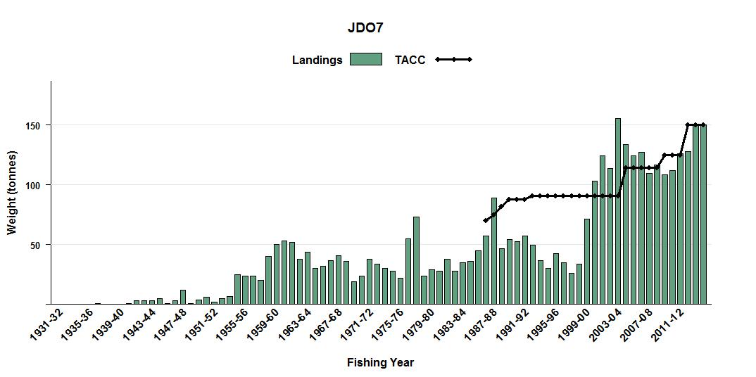
Figure 2: Landings and TACC for JDO 7 from 1931/32 to 2015/16

4.3 Recreational fishery
There is a medium amount of recreational interest in JDO 7. Most John dory in JDO 7 is caught by rod and line with some spearfishing catch and occasional set-net catch.

Regulations governing the recreational harvest of John dory from JDO 7 include a combined maximum daily bag limit of 20. There is a minimum mesh size of 100 mm for nets.

The most recent information on recreational catch available from a National Panel Survey of recreational fisheries. This estimated that 1351 individual fish were harvested in the management area in the 2011/12 fishing year. This is equivalent to a harvest of 1706 kg based on an estimated mean weight of 1.263kg per fish.³ Given ramp surveys indicate an increase in recreational fishing effort since 2011/2012 it is likely that this number of fish exceeds the current recreational allowance of 2 tonnes. MPI notes that there is uncertainty in using the estimate from 2011/12 to estimate or predict current catches. An updated estimate of recreational catch is expected to be available in 2019.
Recreational catch taken from commercial vessels (under Section 111 authorisation) has averaged approximately 110 kg of JDO 7 per year (5 year average).

4.4 Māori customary fishery
John dory is an important kaimoana species for tangata whenua. While John dory is not explicitly stated as a tāonga species in the Te Waka a Māui me ōna toka iwi forum (TWAM) fisheries plan, TWAM regards all species as tāonga species. The South Island customary fishing regulations cover some parts of JDO 7, but not the Tasman Bay/Golden Bay and Marlborough Sounds areas.

Information currently held by MPI on Māori customary catch of JDO 7 is uncertain. There have been no customary authorisations for JDO 7 reported to MPI in the last five years. For those tangata whenua groups operating under the South Island customary fishing regulations, there is a requirement for Tangata Kaitiaki/Tiaki to provide MPI with information on Māori customary harvest of fish. However, for those tangata whenua groups still operating under regulations 50 and 51 of the Fisheries (Amateur Fishing) Regulations 2013 (the Amateur Regulations), it is not mandatory to report on permits issued or catch taken.

The taiāpure of Whakapuaka (Delaware Bay), and the mātaitai reserves of Okuru/Mussel Point, Tauperikaka, Mahitahi/Bruce Bay, Manakaiaua/Hunts Beach. Okarito Lagoon, Te Tai Tapu (Anatori), Te Tai Tapu (Kaihoka) are all within the JDO 7 quota management area. MPI notes that the proposals in this paper will not impact on, or be impacted by, these taiāpure and mātaitai reserves.

4.5 Other sources of fishing-related mortality
There are various potential other sources of fishing-related mortality of JDO 7, but MPI is not able to quantify these precisely. Sources may include discarding to avoid deemed value payments and unseen mortality caused by particular fishing methods. The allowance for other sources of fishing related mortality is currently set at 5% of the TACC. MPI has no information to suggest this proportion should be changed.

4.6 Previous review
The TAC for JDO 7 was last reviewed in 2012 in response to new information from the WCSI trawl survey in 2011.

The TAC was increased from 131 tonnes to 161 tonnes. The TACC was increased from 125 tonnes, to 150 tonnes. Maori customary fishing and recreational allowances were both unchanged. The allowance for other sources of fishing-related was increased to 8 tonnes.

4.7 New information
Information from the most recent inshore trawl survey (including Tasman and Golden Bays, March-April 2015 (KAH1503)) shows that the relative abundance (survey biomass estimate of 487 tonnes for 2015) was the highest in the time series, more than 22% higher than the previous high in 2011 (Figure 3). The 2015 survey biomass estimate of 487 tonnes is assessed as likely (>60%) to be above the target.

In most years a large proportion of JDO 7 biomass has been from the west coast, mostly north of Cape Foulwind. In 2015, less than 30% was from the Tasman and Golden Bay region.

Recruitment is also higher than 2011 and 2013 and almost as strong as 2009. Most of the smaller fish were from the Tasman and Golden Bay region, which is typical of most years.
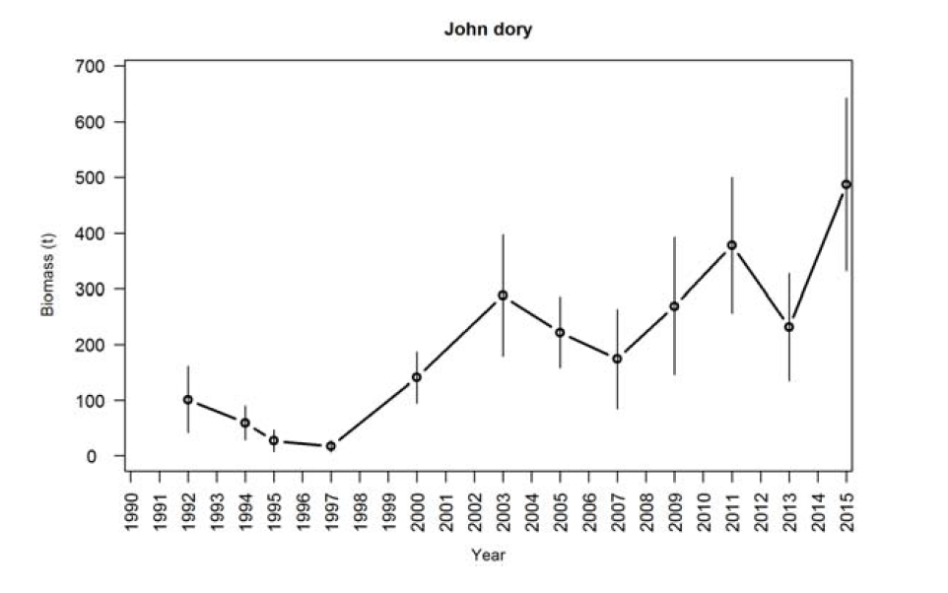
Figure 3: Trends in biomass for JDO 7 from West coast South Island inshore trawl surveys

Legal Considerations

5.1 Setting management measures
The TAC for JDO 7 can be varied under section 13 of the Fisheries Act 1996. Section 13(2) of the Act specifies requirements for setting a TAC where a reliable estimate of the current biomass of the stock and the level of biomass that can produce the maximum sustainable yield (B_{MSY}), is known. In cases such as JDO 7, where B_{MSY} is not known, section 13(2A) of the Act provides for the Minister to use the best available information to set a TAC that is not inconsistent with the objective of maintaining the stock at or above, or moving the stock towards or above, the B_{MSY} level.

An interim target for JDO 7 has been determined as a proxy for B_{MSY} using the average trawl survey biomass between 1992 and 2011. The biomass estimated from the most recent survey (2015) is accepted as a proxy for current biomass and shows that current biomass is likely above the interim target. The options presented are therefore not inconsistent with section 13 requirements.

5.2 Further considerations
Section 12(1)(b) of the Act requires that the Minister provide for the input and participation of tangata whenua and have particular regard to kaitiakitanga before setting or varying a TAC. MPI has informed Te Tau Ihu Forum of the proposals and will be providing further opportunity for engagement on these proposals.

When making a decision concerning the TAC for a stock under section 13(2A), the Minister must have regard to interdependence of stocks, the biological characteristics (discussed earlier) and any environmental conditions affecting the stock.

As John dory are largely a bycatch species, MPI does not anticipate any significant increase in JDO 7 targeting as a result of a TACC increase.

In making any decision the Minister is also obliged to take into account the environmental principles set out in section 9 of the Act. Sections 9(a) and (b) require the Minister to take into account that associated or dependent species be maintained at or above a level that ensures their long-term viability, and that the biological diversity of the aquatic environment should be maintained. Section 9(c) requires the Minister to take into account that habitat of particular significance for fisheries management should be protected.

The key environmental interactions associated with the JDO 7 fishery are discussed below with reference to the likely impacts of the proposed management options.

5.2.1 Seabirds, mammals, and protected fish
Due to their low abundance in both the North and South Island waters, the endemic Hector’s dolphin is declared as a threatened species under the provisions of the Marine Mammals Protection Act 1978.

The set net and bottom trawl (when targeting flatfish) fisheries have been subject to a range of measures designed to reduce interaction of this fishery with Hector’s dolphins and seabirds. The 2015 Plenary report states interactions between the JDO 7 fishery and protected species are believed to be low. MPI considers there will be no significant change to this level of interaction from the proposed measures

5.2.2 Benthic impacts
Research has been reported to characterise both New Zealand’s benthic environment and the level of benthic impact from fisheries activity. This research combined the trawl footprint created for all target species for five years and overlaid benthic habitat classes to get a measure of the coverage of habitat classes by trawl gear.

As John dory are largely a bycatch species, MPI does not anticipate any significant increase in trawling activity nor significant increase of benthic impacts arising from the TACC increases proposed under Option 2 or 3.

Proposed Response
MPI proposes the following options for the upcoming fishing year (Table 3):

Table 3: Proposed TACs, TACCs and allowances for JDO 7 (all values in tonnes)
Option | Total Allowable Catch | Total Allowable Commercial Catch | Allowances
 |  |  | Customary Māori | Recreational | Other sources of fishing-related mortality
Option 1 (Status quo) | 161 | 150 | 1 | 2 | 8
Option 2 | 185 | 170 | 2 | 4 | 9
Option 3 | 206 | 190 | 2 | 4 | 10

6.1 Option 1
Under Option 1, the existing TAC, TACC and allowances would be retained. As the stock is considered to be likely above target the current TAC is not inconsistent with the objective of maintaining the stock at or above, or moving the stock towards or above, a level that can produce the maximum sustainable yield. This option reflects a cautious approach to change given the likely fluctuations in this fishery. However MPI considers that these risks could be mitigated by ongoing monitoring and regular consideration for management review.

Impact
Retaining the current TAC settings will result in opportunity loss for the commercial sector. This is because Option 1 does not enable industry to respond to elevated biomass in a way that would allow them to maximise value. While recreational catches are low relative to commercial the current settings do not account for increasing recreational catch or best available information on recreational fisheries.

6.2 Option 2
Option 2 proposes:
- The TAC be increased from 161 tonnes to 185 tonnes (14.9% increase)
- The TACC be increased from 150 tonnes to 170 tonnes (13.3% increase)
- The customary Māori customary allowance be increased from 1 tonne to 2 tonnes (100% increase)
- The recreational allowance be increased from 2 tonnes to 4 tonnes (100% increae)
- The allowance for other sources of fishing-related mortality would be increased from 8 tonnes to 9 tonnes (12.5% increase) which is approximately 5% of the TACC.

Under Option 2, the existing TAC would be increased by 24 tonnes (approx. 15%). Increasing the TAC amount is not inconsistent with the objective of maintaining the stock at or above, or moving the stock towards or above, a level that can produce the maximum sustainable yield. While specific information is not available to assess the likely impact of this level of increase on stock biomass, a 24 tonne increase is considered relatively small.

If the TAC is increased it is proposed to increase the allowance for customary fishing by 1 tonne, recreational by 2 tonnes and other sources of fishing-related mortality by 1 tonne. The remaining 20 tonne increase would be allocated to the TACC.

MPI proposes providing an allowance for other sources of fishing-related mortality (OSFRM) at 5% of the TACC. While there is no information available to quantify OSFRM, MPI consider that the current allowance is too low, given various other sources of fishing-related mortality. An OSFRM allowance of 5% of the TACC is considered appropriate given the biological characteristics of the stock and mortality caused by the trawling method.

Doubling the recreational and customary allowance accounts for any increases in catch in response to increased biomass. MPI also considers that the recreational allowance better aligns with the latest information from the National Panel Survey. While no customary authorisations for JDO 7 have been reported to MPI in the last five years, MPI notes this information is uncertain. An increase in the customary allowance allows for the exercise of customary rights in the future.

Impact
The increases to allowance are intended to better allow for current fishing in JDO 7.

The commercial sector is the most constrained by the current settings. Increasing the TACC will allow commercial fishers to take advantage of increased abundance of John dory. Based on the 2015/2016 port price of $6.22 per kilogram, an additional commercial catch of 20 tonnes would be worth approximately $124,000 annually.

A 20 tonne (13.3%) increase in the TACC is likely to be a modest response to the increased JDO 7 biomass. With current monitoring through the WCSI trawl survey, it will be possible for MPI to respond to changes in stock biomass (increases and decreases) in a timely manner in future.

6.3 Option 3
Option 3 proposes:
- The TAC be increased from 161 tonnes to 206 tonnes (28.0% increase)
- The TACC be increased from 150 tonnes to 190 tonnes (26.7% increase)
- The customary Māori customary allowance be increased from 1 tonne to 2 tonnes (100% increase)
- The recreational allowance be increased from 2 tonnes to 4 tonnes (100% increase)
- The allowance for other sources of fishing-related mortality would be increased from 8 tonnes to 10 tonnes (25% increase) which is approximately 5% of the TACC.

Under Option 3, the existing TAC would be increased by 44 tonnes. Increasing the TAC is not inconsistent with the objective of maintaining the stock at or above, or moving the stock towards or above, a level that can produce the maximum sustainable yield. While specific information is not available to assess the likely impact of this level of increase on stock biomass, a 45 tonne increase (28%) coupled with ongoing monitoring is considered to be a viable approach to ensuring sustainability of this fishery.

Impact
A 40 tonne (26.7%) increase in the TACC will better provide for increased John dory within the commercial mixed fishery and provide an opportunity to increase utilisation during a period of strong recruitment and elevated biomass. Based on the 2015/2016 port price of $6.22 per kilogram, an additional commercial catch of 40 tonnes would be worth approximately $249,000 annually.

It is expected that the current biomass of JDO 7 will be able to sustain a catch 40 tonnes higher than the current TACC in the short-term while the biomass is high. However, it is also expected that biomass will decline through natural fluctuations overtime; hence, a 190 tonne TACC may not be appropriate in the long-term. MPI recommends that under this option ongoing biennial monitoring through the WCSI trawl survey is essential. The TAC will need to be reviewed again if there are any significant changes in abundance.

The proposed settings for the other sources of fishing-related mortality, recreational and customary allowances under this option are consistent with the rationale provided for Option 2.

Other Matters

7.1 Deemed values
Deemed values are an economic tool that incentivises commercial fishers not to catch in excess of their individual annual catch entitlements. The deemed value rates for JDO 7 were considered as part of the accompanying consultation document “Review of Deemed Value Rates for Selected Stocks” and no changes are proposed.

7.2 Recreational controls
There is no information to suggest a change to recreational controls would be needed and no changes to the recreational daily bag limit are proposed.

Conclusion

Available information on the status of JDO 7 at this time suggests that the stock is experiencing a period of elevated biomass and has been assessed as being Likely (>60%) above the target. The biological characteristics of this stock show that John dory are relatively fast growing and that stock biomass is highly variable and fluctuates in response to strong or weak year classes.

Increasing the TAC and TACC during periods of abundance better provides for increased abundance of John dory within mixed fisheries and creates opportunities for the fishing industry to increase the economic benefits that can be obtained from the fishery.

Option 1 proposes no changes to current management settings. Option 2 proposes the existing TAC is increased by 24 tonnes. This is comprised of a TACC increase of 20 tonnes, a recreational allowance increase of 2 tonnes, and a 1 tonne increase for both the customary allowance and other sources of fishing-related mortality.

Option 3 proposes the existing TAC is increased by 44 tonnes. This is comprised of a TACC increase of 40 tonnes, a recreational allowance and other sources of fishing-related mortality increase of 2 tonnes, and a 1 tonne increase for the customary allowance.

Increasing the TAC by the amounts proposed in Option 2 or 3 is not considered to be inconsistent with the objective of maintaining the stock at or above, or moving the stock towards or above, a level that can produce the maximum sustainable yield.

MPI is seeking information and views from tangata whenua and stakeholders to support the development of final advice to the Minister on management settings for JDO 7 for the fishing year commencing 1 October 2016.

It is important to note that the Minister has broad discretion in exercising his powers of decision-making. He will make his own independent assessment of the information presented to him before making a final decision on varying a TAC, allowances and TACC.

Fisheries (Amateur Fishing) Regulations (2013)
Wynne-Jones J, Gray A, Hill L, Heinmann A (2014) National Panel Survey of Marine Recreational Fishers 2011-2012: Harvest Estimates. New Zealand Fisheries Assessment Report 2014/67. 139p. ³ Hartill B,Davey N (2015) Mean weight estimates for recreational fisheries in 2011-2012. New Zealand Fisheries Assessment Report 2015/25. 37p.
Ministry for Primary Industries (2015) Fisheries Assessment Plenary May 2015: Stock Assessments and Stock Status

